Dr. Mhd. Munthear Alqaderi ,
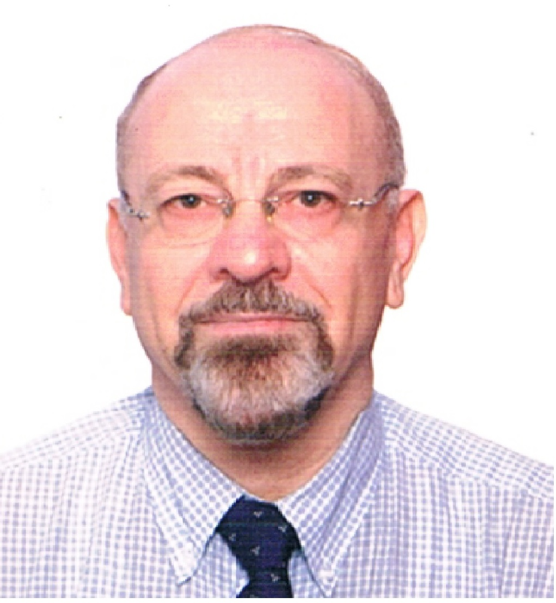
Sultanate of Oman - Muscat
Mobile no. 00968-93569971
E-mail: munthear@gmail.com
Skype: monthear.alqaderi
http://arid.my/0001-0126
www.linkedin.com/in/dr-munthear-alqaderi-9005a03a
www.slideshare.net/munthear
www.researchgate.net/profile/Munthear_Alqaderi
https://twitter.com/munthearalqader
www.youtube.com/watch?v=G0CFtweVt2w
https://independent.academia.edu/ محمدمنذرالقادري

Education
- PhD. 2004-2008,
Computer and Automation Engineering, Damascus Univ., with honor grade.
Thesis title: Adaptive NeuroFuzzy control for Distributed Large Scale Systems.
- M.Sc. 1992-1995,
Computer and Automation Engineering, Damascus Univ., with honor grade.
Thesis title: Optimization Switching Power Converter Design and Simulation.
- Postgraduate Diploma, 1990-1992,
Electrical Power Engineering, Damascus Univ., Syria.
- Postgraduate Diploma, 1990-1991,
Educational Qualification, Damascus Univ., Syria.
- B.Sc. 1976-1981,
Electronics Engineering and Communications, Damascus Univ., Syria.
- Diploma, 2015.
Project Management, ALISON ,Ireland.
- Energy manager Certified, 2016.
Energy University, France.

Professional Certificates
Certificates by Energy Univ. by Schneider Electric:
- Data Center System Planning Certificate
- Understanding Preventive Maintenance for Data Centers Certificate.
- Active Energy Efficiency Using Speed Control Certificate.
- Efficient Motor Control with Power Drives Systems Certificate.
- Building Controls I: An Introduction to Building Controls Certificate.
- Building Controls II: Control Sensors Certificate.
- Data Center Projects: Commissioning Certificate Strategic Energy Planning Certificate.
- Distributed Generation Certificate.
- Power Distribution Certificate.
- Power Factor and Harmonics Certificate.
- Alternative Power Generation Technologies Certificate.
- Enhancing Large UPS Efficiency Certificate.
- A Comparison of AC and DC Power Distribution in the Data Center Certificate.
- Energy Efficiency with Building Automation Systems I Certificate.
- Demand Response and the Smart Grid Certificate.
- ASHE: Energy Manager Energy Management Certificate.
- Enhancing Large UPS Efficiency Certificate.
- Generator Fundamentals Certificate.
- Energy Efficiency Fundamentals Certificate.
- Measuring and Benchmarking Energy Performance Certificate.
- Commissioning For Energy Efficiency Certificate.
- Maintenance Best Practices for Energy Efficient Facilities Certificate.
- Measurement and Verification Including IPMVP Certificate.
- Battery Safety and Environmental Concerns Certificate.
- Battery Technology: Site Planning and Ventilation Certificate.

Professional Certificates:
- “An Introduction to Behavior-Based Safety”, Alison.
- “Electrical Safety Basics” Certificate, OSHAcademy, USA.
- The Safety Management Pack (SMP20), Health and Safety Authority, https://hsalearning.ie
- “Battery Safety and Environmental Concerns”, Energy Univ.
- “Connect IO- A Freeware SoftPLC Programming Tool (FBD)" Certificate, NFI, Industrial Automation Training Academy.
- “Basic Industrial Automation Course- PLC, HMI and VFD” Certificate, NFI, Industrial Automation Training Academy.
- “Maintenance Control Devices and Industrial Automation” Certificate, Arab Federation for Technical Education.
- “Uninterruptible Power Supplies – Advantages and Disadvantages of Various Configurations” Certificate, PDG engineer.

Management and Administration Certificates:
- “Strategic Management” Certificate, Open 2 Study.
- “Principle of Project Management” Certificate, Open 2 Study.
- “Scrum Fundamentals Certified Credential” Certificate, Scrumstud.
- “SWAT Analysis” Certificate, MSG.
- “Lean SixSigma” Certificate, LEANSIXSIGMA.
- “Six Sigma”, Udemy, 2016.
- “Quality Management”, Certificate, Sultan Qaboos Univ.2013.
Honors & Awards
- Gold Medal for innovation and invention, Syria, 2011. http://www.dampress.net/?page=show_det&select_page=6&id=13495
- Gold Medal for innovation and invention, Syria, 2001.
- Gold medal for innovation and invention, Syria, 1999.

Teaching in MEEF, Damascus Univ
- Professor Assistant at the Computer Engineering and Automation Dept., Faculty of Mechanical and Electrical Engineering, Damascus University, 2008 to 2012.
- Lecturer, Electronics Engineering Dept., Damascus University, 1998 to 2008.

Postgraduate courses:
- 2008-2012: "Large-scale systems", Master level.
Undergraduate Courses:
- 2007-2012: “Industrial networks”.
- 2010-2012: “Industrial Power Electronics”.
- 2010-2012: “Fundamentals of Electronic circuits”.
- 1990-2011: “Electronic Circuit Design".
- 2005-2006: “Fuzzy Control”.
- 2004-2005: “Electrical Measurements”.
- 2004-2005: “Foundations of electronic circuits”.
- 2003-2004: “Electronic Measurements”.
- 1990-1992: “Logic Circuit and Digital Systems”.
Lab.:
- 2007-2012: Head of Industrial Networks Lab.
- 2008-2012: Head of Electronic Circuits Lab.
- 1990-2007: Supervisor and Instructor, Logic and Digital Circuits Lab.,
- 1989-1990: Teaching, TV Lab.,

Supervision
M.Sc. projects: Damascus Univ.
- 2008-2011: “Micro stepping driving to minimize the resonance of stepper motor”.
- 2007-2010: “New proposal for Fault diagnostic in SCADA”.
- 2007-2010: “Self-organizing Fuzzy Controller using inverse model”.
- 2008-2009: “Development of algorithm for SOC & SOH Battery identification”.
- 2007-2009: “Modbus/CAN gateway design”.
- 2011: registered "Development of fire detection system".
- 2012: registered "1-Wire network combined with the Modbus network ".
- 2012: registered at Aleppo Univ., "Integration of BMS systems and the development of an algorithm for decision support".
Diploma Projects:
- 1996 to 2005: Supervise many Diploma Projects, in fuzzy control, neural networks, Modeling and Fuzzy Grafcet.
Under graduation Projects:
- 1998 to 2010: I have supervised more than 24 final projects,

Publications
Papers:
- M.M. Alqaderi and Aiman Idrees,”Optimal design of hybrid power generation system to ensure reliable feeding an electric load in a remote area ", Damascus University, 2012.
http://www.damascusuniversity.edu.sy/mag/eng/images/stories/2-2012/A/81-91.pdf
- M.M. Alqaderi and Aiman Idrees, "Modeling and simulation of the PV cell in the LABVIEW environment", Damascus University, 2011.
http://www.damascusuniversity.edu.sy/mag/eng/images/stories/2-2012/A/111-121.pdf
- M.M. Alqaderi, "Development of an intelligent controller using ANFIS works in real-time", Damascus University, 2007.
- M.M. Alqaderi, "Achievement of handling system as a part of a large scale system and its control", Journal of AL Basel of Engineering Science, Ministry of Higher Education, 2007.
- M.M. Alqaderi, "The use of Fuzzy logical controller to control the movement of paper", the Libyan Arab Conference on the Fourth of Electrical and Electronic Engineering, 2006.
- M.M. Alqaderi, "Design of intelligent Hopfield adaptive neural network to determine the harmonics", forty Science Week sessions, University of Teshreen, 2000.
- M.M. Alqaderi, "An Improved Scheme of the Darlington Switch", the Arab School for Science and Technology, Damascus, 1999.
- M.M. Alqaderi, "Reduce the problem of harmonic pollution in electrical grids using the Power active filer", thirty-sixth Science Week sessions, University of Aleppo, 1996.
- M.M. Alqaderi, "Minimize the loss in the semiconductor power switch", thirty-fifth Science Week sessions, University of Teshreen, 1995.
- M.M. Alqaderi, "Optimization Design of a Single-Phase Inverter uses IGBT", thirty-fourth Science Week sessions, University of Damascus, 1994.
Magazine:
1– M.M. Alqaderi, "Enterprise Resource Planning - ERP Software ", Industrial Technology Magazine, 2011, Issue 14. https://issuu.com/khaledsayes/docs/intech_14
2– M.M.Alqaderi, "Battery Types and Specifications”, Industrial Technology Magazine, 2011, Issue 14. https://issuu.com/khaledsayes/docs/intech_14
3 – M.M.Alqaderi, "Programmable Industrial Control - origin and development", Industrial Technology Magazine, 2010, Issue 13. https://issuu.com/khaledsayes/docs/intech_13
4– M.M.Alqaderi, "PLC-programming language of sequential functional charts SFC", Industrial Technologies Magazine, No. 2010.12
5 – M.M.Alqaderi, "Modeling and Simulation in Power Electronics", Computer Information and Technology Magazine, 1997, No. 60.
Books:
- M.M. Alqaderi, “Industrial Networks”, Damascus University Press, 2012.
- M.M. Alqaderi and Zareefe, “Industrial Electronics”, Damascus University Press, 2012.
- M.M. Alqaderi, “Monitoring and Cardiograph Apparatus”, Dar Al Ones, 1992.
- http://www.neelwafurat.com/itempage.aspx?id=egb32559-5032584&search=books
- M.M. Alqaderi, “Electronic Circuits Applications”, Dar Al Ones, 1994.
http://www.furat.com/index.php?Prog=book&Page=bookinfo&id=9642
- M.M. Alqaderi, “X-ray Imaging and Endoscopy”, Dar Al Ones, 1994.

